Name______________________ #_________ Date_____________________

Group Members: _____________________________________________________________

________________________________________________________________

Chapter 3 Project:

1. You will be assigned to one of 4 groups: American Indians, Latinos, European Americans, or Asian Americans. Circle the group you were assigned to.
2. With your table group, watch the video and read about the group you were assigned to in your History Alive book. **Take notes in your organizer as you read.**
3. Create a 5 slide Power Point that explains and shows:

* Slide 1 – Cover slide – the title should be the name of your group – include pictures that represent your group
* Slide 2 – Tell when your group came to the United States and where in America they settled – use text boxes and pictures.
* Slide 3 – Tell why your group came to America and how their experience was when they first arrived – use text boxes and pictures.
* Slide 4 – Tell about the food, traditions and art your group contributed to the U.S. – use text boxes and pictures.
* Slide 5 – Tell about the music, sports, languages, words, and other cool stuff your group contributed to the U.S. – use text boxes and pictures

1. You will have 2 class periods to create your presentation. Be prepared to share your Power Point with the class.



4. Have ONE person (the person in **bold font**) in your group open a blank PowerPoint presentation in Office 365. That person will click the share button at the top right hand side of the page.

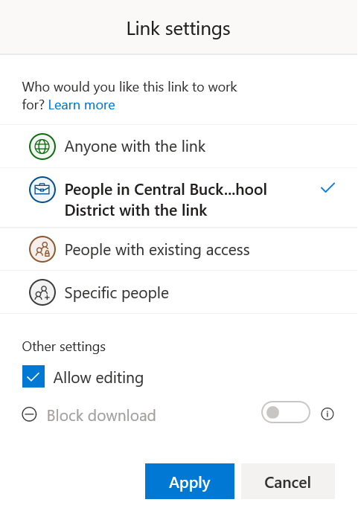That person will allow editing by selecting this button:

Then the person will select allow editing and select apply:

That person will search for the names of the people in their group to share the presentation. Begin typing in the last name of the people in your group and select them when they appear. Make sure it has grade 4 under their name.

Make sure each person in your group works on one slide at a time.

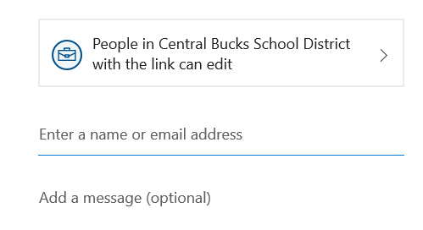

Groups:

Group 1 -American Indians– **William**, Tyler, Jordan, Amelia, Talia

Group 2 – Spanish - **Max**, Adhiti, Sophia, Shokh, Mario

Group 3 – Europeans Americans – **Lyla**, Brooke, Praanya, Charlie, Nihan

Group 4 – Asian Americans – **Leo**, Gia, Timur, Leona, Blake